Name of Policy / Strategy: | Learner Behaviour Policy
Written by: | Justin Speirs
Approved by: | Kathryn Baker | Date: | 18/12/20
Implementation Date: | January 2020
Review date*: | January 2022
This document will be reviewed every 3 years or when there are operational or legislative changes that require a review.
Associated policies, procedures & Strategies: | - Learner Exclusion Policy  - Safeguarding Policy  - Acceptable Use Policy  - Equality & Diversity Policy
Amendments (include date) | May 2021 – addition of ‘Serious Behaviour Incident’ section (2)

- Introduction
SS&L has a clear stance on behaviour and is committed to creating a learning environment where all learners feel safe and are able to achieve their learning potential. We hold high expectations of both our staff and learners’ behaviours and attitudes and will challenge individuals when they fall short of these expectations.
SS&L recognises the multi-faith, multi-cultural and ever-changing nature of the United Kingdom. It also understands the vital role it has in ensuring that the groups or individuals it engages, and the communities in which it operates, are not subject to intimidation or radicalisation by those wishing to unduly, or illegally, influence them.
We follow equal opportunities guidance, implemented through our Equality and Diversity Policy, which guarantees that there will be no discrimination against any individual or group, regardless of age; disability; gender reassignment; race; religion or belief; marriage and civil partnership; pregnancy and maternity; faith, sex; sexual orientation.
As per government guidance, as set out in the 2011 Prevent Strategy, SS&L seeks to embed ‘British Values’ throughout its practice. There are 5 defined British Values:
- Democracy: a culture built upon freedom and equality, where everyone is aware of their rights and responsibilities
- The Rule of Law: the need for rules to make a happy, safe and secure environment to learn and work
- Individual Liberty: protection of your rights and the rights of others you learn and work with
- Mutual Respect & Tolerance of those of different faiths and beliefs: understanding that we don’t all share the same beliefs and values. Respecting the values, ideas and beliefs of others whilst not imposing your own on others
Our aim is to ensure consistency and fairness in the treatment of learners whose behaviour does not meet the standards expected of staff or those participating in learning and breaches the ‘Learner Code of Conduct’.
  - Policy Aims
This policy aims to:
- Ensure a consistent approach to behaviour management
- Outline what SS&L consider to be unacceptable behaviour
- Outline how learners are expected to behave
- Summarise the roles and responsibilities with regards to behaviour management
- Outline the process for dealing with unacceptable behaviour

SS&L Expectations
Learners must:
- Show respect and consideration to staff, other learners and other visitors to SS&L’s centres
- Refrain from verbal abuse or physical violence, foul language, racist or sexist taunts or innuendos
- Comply with SS&L’s Equal and Diversity Policy and treat all members of staff and the community with consideration, courtesy and respect
- Abide by all SS&L regulations regarding the use of IT equipment
- Follow examination board and awarding body regulations
- Extend SS&L’s expectations of behaviour in any work placements

  - Unacceptable Behaviour
When a learner does not meet these expectations, they must be reviewed with the individual or group and consequences determined; as outlined in the behaviour management process.
Examples of what will be considered unacceptable behaviour are (not exhaustive):
- Causing disruption to own or others’ learning
- Being disrespectful to staff and other learners
- Using computers or the internet in a way that is not in line with SS&L’s Acceptable Use Policy
- Any form of bullying (outlined below)
- Plagiarism or any action which contradicts examination boards and awarding bodies regulations
- Racist, sexist, homophobic or discriminatory behaviour
- Any act that in breach of SS&L’s Safeguarding Policy (including Prevent)

  - Bullying

Bullying is defined as the repetitive, intentional harming of one person or group by another person or group, where the relationship involves an imbalance of power. It can be emotional, physical, racial, sexual, direct or indirect verbal or cyber. Bullying is, therefore:

- Deliberately hurtful
- Repeated, often over a period of time
- Difficult to defend against

- Serious Behaviour Incidents

A serious behaviour incident is defined as:
- Repeated breaches of SS&L expectations
- Any form of bullying
- Sexual assault, which is any unwanted sexual behaviour that causes humiliation, pain, fear or intimidation
- Vandalism
- Theft
- Fighting, physical assaults and any form of violent behaviour
- Possession of any prohibited items, including, but not limited to:
  - Knives or any form of weapon
  - Alcohol
  - Illegal drugs
  - Stolen items
  - Pornography

Any learner committing a serious behaviour incident will, in most circumstances, be excluded with immediate effect. Exclusions could be fixed-term exclusions or permanent exclusions.

- ROLES & RESPONSIBILITIES
  - Strategic Planning Team
The Strategic Planning Team is responsible for monitoring the effectiveness of this policy and holding the Director of Curriculum & Quality accountable for its effective implementation.

  - Director of Curriculum & Quality
The Director of Curriculum & Quality is responsible for reviewing this policy. They will ensure that SS&L’s learning environment encourages positive behaviour and that staff manage behaviour effectively, as well as monitoring how staff implement this policy to ensure a consistent approach to behaviour management.

  - Delivery Managers
The Delivery Managers will monitor the implementation of this policy within their own curriculum areas across their staff teams. They will also support Sector Team Leaders and tutors in responding to incidents of unacceptable behaviour. Delivery Managers will also lead on any incidents that escalate to stage ‘3’ of the behaviour management process (see below).

  - Sector Team Leaders
Sector Team Leaders will ensure that this policy is implemented effectively within their sector area, monitoring how tutors manage behaviour in line with this policy ensuring a consistent approach is used.

  - Tutors
Tutors are responsible for setting the tone and context for positive behaviour within the various learning environments in line with this policy. They will challenge unacceptable behaviour swiftly, following the behaviour management process (see below). Tutors will also keep an accurate record of all incidents of unacceptable behaviour, reporting them to Sector Team Leaders if necessary.

- Behaviour Management Process
Tutors are responsible for their classes and have initial responsibility for managing behaviour in a classroom or other teaching environment; including online lessons.
Well-prepared and well-organised teaching should take into account behaviour management. A code of conduct should be agreed with learners as part of their induction. If unacceptable behaviour does arise, it should not be ignored and should be challenged/suitably addressed at an early stage.
An individual displaying unacceptable behaviour must be reminded of the expectations of learners and the agreed code of conduct. The process for dealing with unacceptable behaviour should be clearly outlined to ensure the learner clearly understand the consequences of continued or repeated unacceptable behaviour (see below).
Any incidents must always be reported to the relevant Sector Team Leader, who will consult with their Delivery Manager and instigate the necessary Learner Disciplinary process (see below).

  - STAGES IN DEALING WITH UNACCEPTABLE BEHAVIOUR

    - Stage One of the Behaviour Management Process
This stage must be carried out as soon as the behaviour is identified and within 24 hours.
Informal discreet approach by tutor/other member of staff. Sector Team Leader informed. Note made of incident on ILP, under the Pastoral section of EBS, with date of incident. The document should then be uploaded under Documents on EBS. Cause for Concern form completed if appropriate (annex 1). The learner should be informed at what stage they are in the disciplinary process and what the next stage is should the behaviour not improve or any agreed actions completed.

    - Stage Two of the Behaviour Management Process
This stage should be set up as soon as it has been approved by a line manager or a delivery manager and carried out within 10 working days.
A formal disciplinary interview is conducted by the tutor where behaviour is giving cause for concern. Learner may wish to be accompanied. If the learner is under 18, a parent should be invited.

Depending on the outcome of the disciplinary interview and any investigation that is required, a formal written warning may be issued at this stage. The learner should be informed at what stage they are in the disciplinary process and what the next stage is should the behaviour not improve or any agreed actions completed.

The learner will be asked to sign that they have read and understood this statement on the cause for concern form (annex 1) at the time of the interview, and will be given a copy. The document should be uploaded to the Documents section of EBS, and a copy sent to the Sector Team Leader.

    - Stage Three of the Behaviour Management Process
This stage should be set up as soon as it has been approved by a line manager or a delivery manager and carried out within 10 working days.
For repeated misconduct or severe misconduct, a prompt investigation and disciplinary hearing is conducted by the Delivery Manager or by a delegated alternative with no prior direct involvement in the incident(s).

A disciplinary hearing should be set up and the learner invited to hear the evidence gained through the investigation. The learner can be accompanied. If the learner is under 18, a parent/guardian should be invited.

A decision is made as to the most appropriate outcome. Examples of possible outcomes:
- Verbal warning
- Written warning
- Final written warning
- Withdrawal from course/programme

Intimidating or unacceptable behaviour may lead to permanent or temporary exclusion. Authority for permanent exclusion may only arise as a consequence of a disciplinary hearing, and the rationale for taking this action must be formally recorded.

If a learner disagrees with the outcome of the hearing, they are entitled to appeal. Their appeal request should be made to the Director of Curriculum & Quality.

    - Stage Four of the Behaviour Management Process
This stage should be set up as soon at the appeal has been submitted and carried out within 5 working days.
Should the learner wish to appeal the decision, an appeal hearing by the relevant Delivery Manager or by a delegated alternative with no prior direct involvement in the case should be set up in order to hear the appeal.

The decision on the outcome of an appeal hearing is final.

  - Process Map of Behaviour Management Process
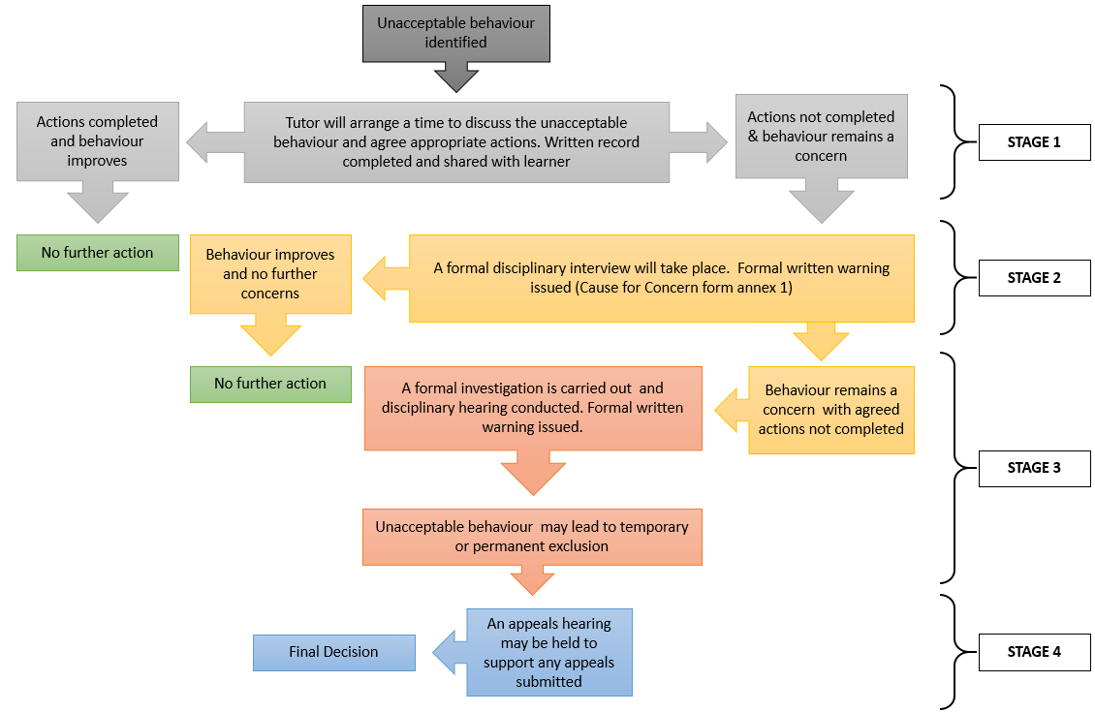

Annex 1

BEHAVIOUR
CAUSE FOR CONCERN

N.B. This form may be used as evidence so must be accurate and tidy

Learner Name:
Course Title:
Tutors Name:
Witness (if appropriate):

Report of Cause for Concern
(give details and date and whether this is a repeated cause of concern)

Record of Discussion with Learner

Agreed Further Action

Learner signature confirming their understanding of the content of this form
Signature: | Date:

Tutor Signature: | Date:
Original uploaded to learner file on EBS and a copy sent to Sector Team Leader

