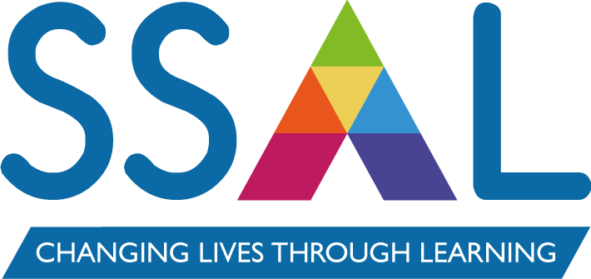

Name of Policy / Strategy: | Safeguarding Policy and Operating Practices
Written by: | Justin Speirs, Director of Curriculum & Quality
Approved by: | SS&L Board | Date: | September 2025
Implementation Date: | September 2025
Review date*: | September 2026
Associated policies, procedures & Strategies: | - Equality & Diversity Policy  - Safer Recruitment Policy  - Acceptable Use Policy  - Health & Safety Policy  - Prevent Risk Assessment  - Whistleblowing Policy
Amendments (include date) | July 2025  - Addition of low-level concerns to policy  - Addition of specific reference to online safety  - Addition of requirement for medical forms for all under 18s and learners up to 25 with an EHCP  - Update of job titles  May 2025  - Updated DSL  September 2024  - Updated DSL and Safeguarding Officers  June 2024  - Revised policy statement  - Updated links

Policy Statement

SS&L is fully committed to providing a safe learning and working environment where all learners and staff are free from harm and abuse. A culture of vigilance is actively promoted across the organisation, including the Board of Directors, through appropriate training and clearly defined roles, responsibilities and procedures for safeguarding. SS&L recognises 'Prevent' as an intrinsic part of safeguarding.
Under the United Kingdom Government's 'Counter-Terrorism and Security Act 2015' a requirement was laid upon "specified authorities" including 'Training Providers', when exercising their functions, to have due regard to the need to PREVENT people from being drawn into terrorism.
The SS&L Board is fully committed to safeguarding including promoting the welfare of all learners and staff against radicalisation and extremism.
This statement reinforces the requirement for all staff at SS&L and its partners to be fully engaged about being extra vigilant regarding safeguarding, radicalisation, and extremism. The company remains committed to continuing to work in partnership with professional bodies, external agencies, and partners in our local community, to ensure that all learners are safe from harm.
All staff, learners and services contracted to SS&L are required to uphold and promote the fundamental principles of 'Human Rights and British Values' and exemplify these in their practice, including democracy; the rule of law; individual liberty; mutual respect and tolerance of those with different faiths and beliefs.

Background

This policy has been drawn up in accordance with legislation, policy and guidance that seeks to protect children, young people and vulnerable adults from harm and abuse.

SS&L's policies and procedures cover arrangements not just for meeting the welfare and safeguarding needs of children, but also the needs of vulnerable adults and young people as well as ensuring appropriate practices for staff recruitment and selection. SS&L recognise that it forms part of the wider safeguarding system for children. This system is described in statutory guidance Working Together to Safeguard Children.

In September 2023 the Department for Education and Skills updated the statutory guidance document Keeping Children Safe in Education. This document focuses on the safeguarding and promoting the welfare of children under the provisions of the Children Act 2004.

In accordance with the Counter-Terrorism and Security Act 2015, there is a statutory duty on training providers to "have due regard to the need to prevent people from being drawn into terrorism". This is known as the Prevent Duty. To fulfil this duty, SS&L has a presence on Somerset's Prevent Board to receive regular updates regarding local concerns and share best practice. We also link with local and regional networks to maintain up to date CPD opportunities.

Scope

This Safeguarding Policy applies to:
- all SS&L staff or anyone working on behalf of or volunteering for SS&L, whether they work in a SS&L centre or off site.
- all learners, whether they are in a SS&L centre or off site at another designated venue.
- all learners, whether a child, a young person or an adult.
- all learners on work experience and work placement programmes.
- to all working arrangements, such as subcontracts with other organisations, whether the activity is carried out at a SS&L centre or off site.

Roles and Responsibilities

Designated Safeguarding Lead (DSL) - The Designated Safeguarding Lead (DSL) with lead responsibility for safeguarding is Justin Speirs, Director of Curriculum & Quality

The DSL is responsible for:
- overseeing the referral of alleged harm or abuse to the relevant agencies.
- seek the appropriate advice and guidance from relevant agencies to support referrals.
- providing advice and support to staff on issues relating to safeguarding.
- maintaining records of any safeguarding referral, complaint or concern.
- ensuring all staff receive initial and follow up safeguarding.
- implementing, monitoring and reviewing SS&L's Safeguarding Policy & procedures.
- Induction of all staff.
- Implement, review and monitor SS&L's Prevent risk assessment.

Safeguarding Officers who support the DSL and deputise in their absence – Karen Savill, Work-based Learning Delivery Manager and Tracey Mortimore, Adult Skills Delivery Manager will act as Deputy DSLs. However, the responsibility for safeguarding, as set out above, will remain with the Designated Safeguarding Lead and will not be delegated. One of the Safeguarding Officers will be assigned to provide short-term cover for the DSL, should the DSL not be available and to consult on safeguarding concerns, policy and procedures.

Operational Safeguarding Lead – Tracey Smith, Finance & Resource Manager will lead on all operational functions relating to safeguarding.

The Operational Safeguarding Lead is responsible for:
- implementing, monitoring and reviewing SS&L's Safer Recruitment Policy & procedures.
- implementing, monitoring and reviewing SS&L's Health & Safety Policy & procedures.
- implementing, monitoring and reviewing SS&L's IT Usage Policy & procedures.
- Work with the DSL to implement, review and monitor the company's Prevent risk assessment.

Board of Directors - The Board of Directors will agree and approve SS&L’s Safeguarding Policy and supporting procedures, while providing leadership and scrutiny to ensure the safety of all learners and staff.

The CEO and Director of Curriculum & Quality will ensure safeguarding is appropriately resourced to ensure the safety of learners and staff. They will also manage any complaints made against staff.

Line Managers will manage the implementation of safeguarding procedures in their area and ensure that safeguarding is a standing agenda item in all team meetings.

All Staff are responsible for:
- complying with SS&L's Safeguarding Policy and procedures, including training requirements.
- promoting a safe learning environment.
- immediately referring any issues or concerns to the DSL and/or Safeguarding Officers.

Reporting a Safeguarding Concern

Learners Raising a Concern
Learners can raise a concern by:
- speaking with their tutor or another member of staff.
- contacting the Designated Safeguarding Lead directly or one of the Safeguarding Officers.

Staff or Partners Raising a Concern
Staff or partners can raise a concern by:
- speaking with their line manager or contract manager.
- contacting the Designated Safeguarding Lead directly or one of the Safeguarding Officers.

Where staff do not feel comfortable to raise a concern, there is an anonymous feedback to CEO mechanism. Staff should also refer to the company’s Whistleblowing Policy for guidance.

Learners who are under 18 or up to 25 with an EHCP

Medical forms must be completed and signed for all learners who are under 18 or up to 25 if they have an Education and Health Care Plan (EHCP). The medical form must contain all medical information and emergency contacts for parents/guardians.

Contact Details for Reporting a Concern

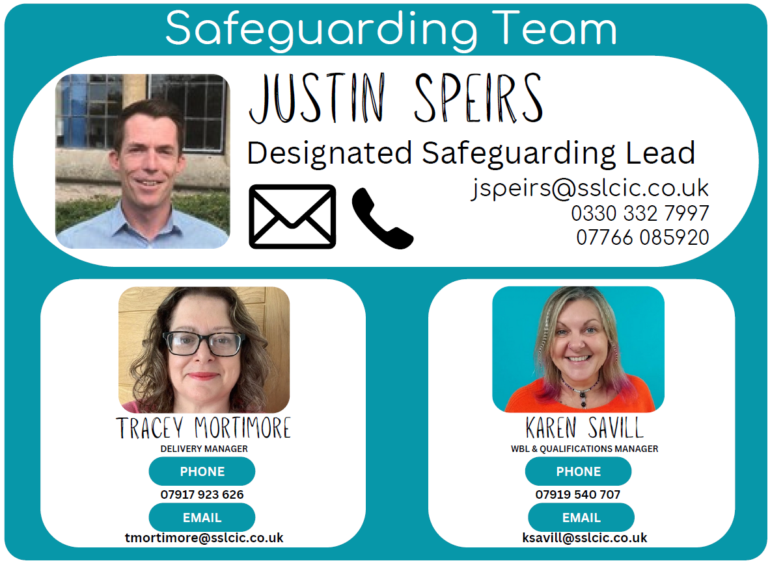

In an emergency situation, always call 999 in the first instance

If an act of abuse or neglect of a vulnerable adult, young person or child is identified or suspected then the SS&L staff member should:
- Stop everything else and concentrate on what you are observing or being told.
- Check that the environment is appropriate and that you are safeguarding yourself.
- Ensure the person's (and any others') immediate safety.
- Do not promise confidentiality or agree to keep something secret.
- Do not investigate yourself and avoid asking leading questions.
- Obtain the necessary information to make an informed referral.
- Refer the matter to the Designated Safeguarding Lead and/or Safeguarding Officers (as above).
- Ensure that the concern has been received by the DSL or one of the Safeguarding Officers.
- Inform your line manager.

Training and Development

All Staff
Safeguarding and Prevent training are mandatory for all staff, including all tutors and assessors engaged with SS&L learners via subcontracting or partnership arrangements. Comprehensive on-line training programmes for Safeguarding and Prevent are required to be undertaken by all staff every 3 years. Safeguarding updates are delivered annually to all staff. Staff are required to read all safeguarding communications and updates such as those sent out through 'Pass it on' and email.

Designated Safeguarding Lead Training
The Designated Safeguarding Lead and the Safeguarding Officers are required to undertake nationally recognised Level 3 Designated Safeguarding Lead training every 2 years.

Finance & Resources Manager
The Finance & Resources Manager is required to undertake nationally recognised Safer Recruitment training every 3 years.

Apprenticeships & Study Programmes
Employers have a duty to comply with UK legislation and their statutory responsibilities. There is an expectation that employers should take responsibility for learners' welfare in the workplace and to seek appropriate advice when they feel a learner may be at risk outside of work.

SS&L appreciate that for some organisations this can be a complicated and confusing area and therefore will provide support to the employer to:
- familiarise themselves with relevant legislation.
- understand what safeguarding means in practice, in the context of their responsibilities.
- demonstrate a commitment to the principles of the Prevent Duty.
- demonstrate a commitment to British Values and adhere to the Equality Act 2010.
- ensure learners are aware of their policies, including their IT policy.
- have an appointed person to coordinate safeguarding across their organisation.

SS&L will ensure that both the employer and the learner are aware of the processes for reporting any safeguarding concerns, as outlined in this policy.

Subcontractors

By subcontractor, SS&L refers to organisations that are contracted to deliver on the behalf of SS&L. In these cases, it is a requirement that any sub-contractors of SS&L will:
- ensure their staff are trained in safeguarding and Prevent.
- ensure relevant staff have DBS.
- have access to SS&L on-line training on request.

Monitoring of safeguarding and the Prevent agenda will be robustly carried out in regular reviews of sub-contracted delivery.

Low-Level Concerns

At SS&L we are committed to safeguarding children and promoting their welfare at all times.

Definition of ‘low-level’ concerns
The term ‘low-level’ concern is any concern – no matter how small – that an adult working in, or on behalf of, the company may have acted in a way that:
- Is inconsistent with the staff code of conduct, including inappropriate conduct outside of work
- Does not meet the harm threshold or is otherwise not considered serious enough to consider a referral to the local authority designated officer (LADO).
The behaviour of the staff, student or volunteer may not relate directly to a particular learner or learners, but may raise an issue or issues of concern with respect to safeguarding. This may potentially call into question the adult’s suitability to work with children or adults in vulnerable situations.

Examples of such behaviour could include, but are not limited to:
- Being overly friendly with children
- Having favourites
- Taking photographs of children on their mobile phone
- Engaging with a child on a one-to-one basis in a secluded area or behind a closed door
- Using inappropriate sexualised, intimidating or offensive language
- Inadvertent or thoughtless behaviour
- Behaviour that might be considered inappropriate depending on the circumstances
- Behaviour which is intended to enable abuse.

Sharing low-level concerns
We recognise the importance of creating a culture of openness, trust and transparency to encourage all staff to share low-level concerns so that they can be addressed appropriately.

We create this culture by:
- Ensuring all staff are clear about what appropriate behaviour is, and are confident in differentiating expected and appropriate behaviour from concerning, challenging or inappropriate behaviour, in themselves and other adults
- Having clear policies and procedures
- Empowering staff to share any low-level concerns
- Empowering staff to self-refer
- Addressing unprofessional behaviour and supporting the individual to correct it at an early stage
- Providing a responsive, sensitive and proportionate handling of such concerns when they are raised
- Helping to reflect on and identify any weakness in the company’s safeguarding procedure.
A low-level concern about a member of staff should be reported to the Designated Safeguarding Lead (DSL) and the manager following SS&L’s safeguarding procedures.

Responding to low-level concerns
- If the concern is raised via a third party, the DSL/manager will collect evidence where necessary by speaking directly to the staff who raised the concern, unless it has been raised anonymously, regardless of whether a written summary has been provided
- If the staff member who raises the concern does not wish to be named, then the company should respect that person’s wishes as far as possible. However, there may be circumstances where the staff member who raises the concern will need to be named (for example, where it is necessary in order to carry out a fair disciplinary process) and, for this reason, anonymity should never be promised to members of staff who share low-level concerns. Where possible, we will encourage staff to consent to be named, as this will help to create a culture of openness and transparency
- The DSL/manager will speak to any potential witnesses, unless advised not to do so by the LADO/other relevant external agencies, where they have been contacted
- The DSL/manager will speak to the staff member about whom the low-level concern has been raised, unless advised not to do so by the LADO/other relevant external agencies, where they have been contacted
- The DSL/manager will use the information collected to categorise the type of behaviour and determine any further action
- Allegations that meet the harm threshold will be referred to the LADO or appropriate service for advice
- Low-level concerns that the company feel may need further guidance on will be referred to the LADO for advice
- Low-level concerns that the company feel we can deal with internally will be dealt with via the company’s safeguarding procedures and/or Disciplinary procedures
- Where a low-level concern relates to agency staff, we will notify the agency, so any potential patterns of inappropriate behaviour can be identified.
Record keeping
All low-level concerns will be recorded in writing. In addition to details of the concern raised, records will include the context in which the concern was raised, any action taken and the reasons for decisions and action taken.

Records will be:
- Reviewed so that potential patterns of concerning, difficult or inappropriate behaviour can be identified
- Retained at least until the volunteer, learner or staff leaves employment at the company
- Kept confidentially, held securely and comply with Data Protection Act 2018 (DPA 2018) and UK GDPR procedure.

Reviewing low-level concerns
When reviewing records of low-level concerns, patterns of concerning, challenging or inappropriate behaviour may be identified. When this occurs, the DSL/manager will decide on a course of action, which may include:
- Disciplinary investigation and/or proceedings
- Management advice, including recommendations for training
- Referral to the LADO or appropriate external agency (where a pattern of behaviour moves from a concern to meeting the harm threshold).

Pre-employment references
We will not include low-level concerns in references unless:
- The concern (or group of concerns) has met the threshold for referral to the designated officer at the local authority (LADO) and is found to be substantiated
and/or
- The concern (or group of concerns) relates to issues which would be included in a reference, such as misconduct or poor performance.

Online Safety

SS&L recognises that safeguarding extends to the digital environment. We are committed to keeping learners safe online, including when using emerging technologies such as artificial intelligence (AI). Learners and staff will be supported to use digital platforms and AI responsibly; understanding both the opportunities and risks they present. Training and guidance will emphasise online safety, data protection, critical evaluation of digital content, and respectful behaviour in online spaces. Any concerns relating to online activity or the misuse of AI should be reported in line with our safeguarding procedures.

Safe Use of AI and Digital Tools
- AI and digital platforms (including chatbots, content generators, and learning technologies) should only be used in a way that supports learning and personal development.
- Learners must be aware of risks such as:
  - Exposure to inappropriate or biased content.
  - Misinformation or “hallucinations” (incorrect outputs).
  - Privacy concerns when sharing personal information with AI tools.
  - Over-reliance on AI instead of developing independent skills.
- Staff should guide learners to use AI responsibly, ethically, and safely — for example, by encouraging cross-checking information and protecting personal data.
- The organisation should monitor and regularly review which digital/AI tools are permitted for use in learning, ensuring they are age-appropriate and compliant with safeguarding and data protection requirements.
- Learners should be signposted to and supported with SS&L’s Acceptable Use Policy and Learner Behaviour Policy.

