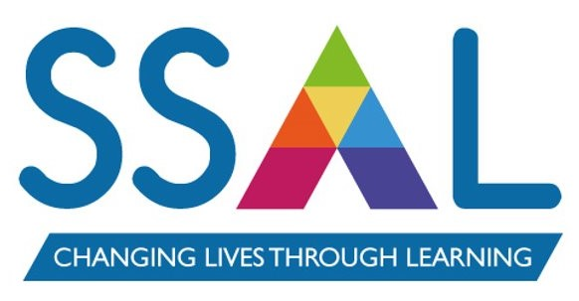

Name of Policy / Strategy: | Learner Behaviour Policy
Written by: | Justin Speirs
Approved by: | Kathryn Baker, CEO | Date: | 14/11/23
Implementation Date: | November 2023
Review date*:
This document will be reviewed every 3 years or when there are operational or legislative changes that require a review.
Associated policies, procedures & Strategies: | - Learner Exclusion Policy  - Safeguarding Policy  - Acceptable Use Policy  - Equality & Diversity Policy
Amendments (include date) | November 2023  - Re-order of serious incidents to make the Policy easier to read and understand  - Addition of Xenophobia to serious incidents  - Further reference to links between policy behaviour expectations and the Fundamental British Values  - Removal of reference to Tribal’s Engage app  - Update of job titles and team names, where these have changed since the last review

- Introduction
SS&L has a clear stance on behaviour and is committed to creating a learning environment where all learners feel safe and are able to achieve their learning potential. We hold high expectations of both our staff and learners’ behaviours and attitudes and will challenge individuals when they fall short of these expectations.
SS&L recognises the multi-faith, multi-cultural and ever-changing nature of the United Kingdom. It also understands the vital role it has in ensuring that the groups or individuals it engages, and the communities in which it operates, are not subject to intimidation or radicalisation by those wishing to unduly, or illegally, influence them.
We follow equal opportunities guidance, implemented through our Equality and Diversity Policy, which guarantees that there will be no discrimination against any individual or group, regardless of age; disability; gender reassignment; race; religion or belief; marriage and civil partnership; pregnancy and maternity; faith, sex; sexual orientation.
As per government guidance, as set out in the 2011 Prevent Strategy, SS&L seeks to embed ‘British Values’ throughout its practice. There are 5 defined British Values:
- Democracy: a culture built upon freedom and equality, where everyone is aware of their rights and responsibilities
- The Rule of Law: the need for rules to make a happy, safe and secure environment to learn and work
- Individual Liberty: protection of your rights and the rights of others you learn and work with
- Mutual Respect & Tolerance of those of different faiths and beliefs: understanding that we don’t all share the same beliefs and values. Respecting the values, ideas and beliefs of others whilst not imposing your own on others
Our aim is to ensure consistency and fairness in the treatment of learners whose behaviour does not meet the standards expected of staff or those participating in learning
Policy Aims
This policy aims to:
- Ensure a consistent approach to behaviour management
- Outline what SS&L considers to be unacceptable behaviour
- Outline how learners are expected to behave
- Summarise the roles and responsibilities with regards to behaviour management
- Outline the process for dealing with unacceptable behaviour

- SS&L Expectations
Learners must:
- Show respect and consideration to staff, other learners and other visitors to SS&L’s centres
- Refrain from verbal abuse or physical violence, foul language, racist or sexist taunts or innuendos; whether face-to-face, via text or online
- Comply with SS&L’s Equality and Diversity Policy and treat all members of staff and the community with consideration, courtesy and respect
- Abide by all SS&L regulations regarding the use of IT equipment
- Follow examination board and awarding body regulations
- Extend SS&L’s expectations of behaviour in any work placements

- Unacceptable Behaviour
When a learner does not meet the behavioural expectations set out in this Policy, the expectations and unacceptable behaviours must be reviewed with the individual or group and consequences determined; as outlined in the behaviour management process.
Examples of what will be considered unacceptable behaviour are (not exhaustive):
- Causing disruption to own or others’ learning
- Being disrespectful to staff and other learners
- Using computers or the internet in a way that is not in line with SS&L’s Acceptable Use Policy
- Any form of bullying (outlined below)
- Discriminatory behaviour that falls outside of the Fundamental British Values (detailed above)
- Any act that in breach of SS&L’s Safeguarding Policy (including Prevent)
- Plagiarism or any action which contradicts examination boards and awarding bodies regulations

  - Serious Behaviour Incidents

Any learner committing a serious behaviour incident will, in most circumstances, be excluded with immediate effect. Exclusions, in line with SS&L’s Exclusion Policy, could be fixed-term exclusions or permanent exclusions. A serious behaviour incident is defined as:

- Repeated breaches of SS&L expectations
- Any form of bullying
- Sexual assault, which is any unwanted sexual behaviour that causes humiliation, pain, fear or intimidation
- Racism
- Xenophobia
- Sexism
- Homophobia
- Vandalism
- Theft
- Threats of violence
- Fighting, physical assaults and any form of violent behaviour
- Possession of any prohibited items, including, but not limited to:
  - Knives or any form of weapon
  - Alcohol
  - Illegal drugs
  - Stolen items
  - Pornography

  - Bullying

Bullying is defined as the repetitive, intentional harming of one person or group by another person or group, where the relationship involves an imbalance of power. It can be emotional, physical, racial, sexual, direct or indirect verbal or cyber. This includes any intentionally malicious or insulting behaviour. Bullying is, therefore:

- Deliberately hurtful
- Repeated, often over a period of time
- Difficult to defend against

  - Sexual Harassment

Sexual harassment is unlawful under the Equality Act 2010. It is also unlawful to treat someone less favourably as a result of submitting either a complaint of sexual harassment or have rejected such behaviour. Under the Equality Act, sexual harassment is defined as occurring when a person engages in unwanted conduct of a sexual nature that has the purpose or effect of:

- violating someone’s dignity, or
- creating an intimidating, hostile, degrading, humiliating or offensive environment for them.

Sexual harassment includes a wide range of behaviours, including, but not limited to:

- sexual comments or jokes
- displaying sexually graphic pictures, posters or photos
- suggestive looks, staring or leering
- propositions or sexual advances
- making promises in return for sexual favours
- sexual gestures
- intrusive questions about a person’s private or sex life, and discussing your own sex life
- sexual posts or contact on social media
- spreading sexual rumours about a person
- sending sexually explicit emails, text messages or social media posts
- unwelcome touching, hugging, massaging or kissing
- criminal behaviour, including sexual assault, stalking, grooming, indecent exposure and sending offensive communications
- predatory behaviour
- coercion

SS&L takes all reports of unacceptable behaviour extremely seriously. All learners and staff are encouraged to report any unacceptable behaviour as soon as possible and will be supported through the process.

- Reporting Channels

  - Designated Safeguarding Lead (DSL)

Name: Justin Speirs
Email: jspeirs@sslcic.co.uk
Mobile: 07766 085 920
Phone: 0330 332 7997

The DSL’s contact details is on posters in all SS&L classrooms and in toilets in each of our centres.

  - Deputy Designated Safeguarding Lead

Name: Justin Speirs
Email: jspeirs@sslcic.co.uk
Mobile: 07766 085920

  - Report a Concern Icon on Desktop Computers

All computers on SS&L sites which are available for learners to access has a ‘Report a Concern’ icon on the desktop. By clicking this icon, a concern can be raised directly with the DSL.

- ROLES & RESPONSIBILITIES
  - Board of Directors through the CEO
The CEO responsible for monitoring the effectiveness of this policy and holding the Director of Curriculum & Quality accountable for its effective implementation.

  - Director of Curriculum & Quality
The Director of Curriculum & Quality is responsible for reviewing this policy. They will ensure that SS&L’s learning environment encourages positive behaviour and that staff manage behaviour effectively, as well as monitoring how staff implement this policy to ensure a consistent approach to behaviour management.

  - Delivery Managers/Head of Curriculum
The Delivery Managers will monitor the implementation of this policy within their own curriculum areas across their staff teams. They will also support Sector Team Leaders and tutors in responding to incidents of unacceptable behaviour. Delivery Managers will also lead on any incidents that escalate to stage ‘3’ of the behaviour management process (see below).

  - Course Leaders
Sector Team Leaders will ensure that this policy is implemented effectively within their sector area, monitoring how tutors manage behaviour in line with this policy ensuring a consistent approach is used.

  - Tutors
Tutors are responsible for setting the tone and context for positive behaviour within the various learning environments in line with this policy. They will challenge unacceptable behaviour swiftly, following the behaviour management process (see below). Tutors will also keep an accurate record of all incidents of unacceptable behaviour, reporting them to Sector Team Leaders if necessary.

- Behaviour Management Process
Tutors are responsible for their classes and have initial responsibility for managing behaviour in a classroom or other teaching environment; including online lessons.
Well-prepared and well-organised teaching should take into account behaviour management. A code of conduct should be agreed with learners as part of their induction. If unacceptable behaviour does arise, it should not be ignored and should be challenged and suitably addressed at an early stage.
An individual displaying unacceptable behaviour must be reminded of the expectations of learners and the agreed code of conduct. The process for dealing with unacceptable behaviour should be clearly outlined to ensure the learner clearly understand the consequences of continued or repeated unacceptable behaviour (see below).
Any incidents must always be reported to the relevant Course Leader, who will consult with their Delivery Manager and instigate the necessary Learner Disciplinary process (see below).
  - STAGES IN DEALING WITH UNACCEPTABLE BEHAVIOUR

    - Stage One of the Behaviour Management Process
This stage must be carried out as soon as the behaviour is identified and within 24 hours.
Informal discreet approach by tutor/other member of staff. Course Leader informed. Note made of incident on ILP, with date of incident. Cause for Concern form completed if appropriate (annex 1). The learner should be informed at what stage they are in the disciplinary process and what the next stage is, should the behaviour not improve or any agreed actions completed.

    - Stage Two of the Behaviour Management Process
This stage should be set up as soon as it has been approved by a line manager or a delivery manager and carried out within 10 working days.
A formal disciplinary interview is conducted by the tutor where behaviour is giving cause for concern. Learner may wish to be accompanied. If the learner is under 18, a parent should be invited to the disciplinary interview.

Depending on the outcome of the disciplinary interview and any investigation that is required, a formal written warning may be issued at this stage. The learner should be informed at what stage they are in the disciplinary process and what the next stage is should the behaviour not improve or any agreed actions completed.

The learner will be asked to sign that they have read and understood this statement on the cause for concern form (annex 1) at the time of the interview, and will be given a copy. The document should be uploaded to the Documents section of EBS, and a copy sent to the Course Leader.

    - Stage Three of the Behaviour Management Process
This stage should be set up as soon as it has been approved by a line manager or a delivery manager and carried out within 10 working days.
For repeated misconduct or Serious Behaviour Incident, a prompt investigation and disciplinary hearing is conducted by the Delivery Manager or by a delegated alternative with no prior direct involvement in the incident(s).

A disciplinary hearing should be set up and the learner invited to hear the evidence gained through the investigation. The learner can be accompanied. If the learner is under 18, a parent/guardian should be invited.

A decision is made as to the most appropriate outcome. Examples of possible outcomes:
- Verbal warning
- Written warning
- Final written warning
- Withdrawal from course/programme (in line with SS&L’s Exclusion Policy)

Intimidating or unacceptable behaviour may lead to permanent or temporary exclusion. Authority for permanent exclusion may only arise as a consequence of a disciplinary hearing, and the rationale for taking this action must be formally recorded.

If a learner disagrees with the outcome of the hearing, they are entitled to appeal. Their appeal request should be made to the Director of Curriculum & Quality.

    - Stage Four of the Behaviour Management Process
This stage should be set up as soon at the appeal has been submitted and carried out within 5 working days.
Should the learner wish to appeal the decision, an appeal hearing by the relevant Delivery Manager or by a delegated alternative with no prior direct involvement in the case should be set up in order to hear the appeal.

The decision on the outcome of an appeal hearing is final.

  - Process Map of Behaviour Management Process
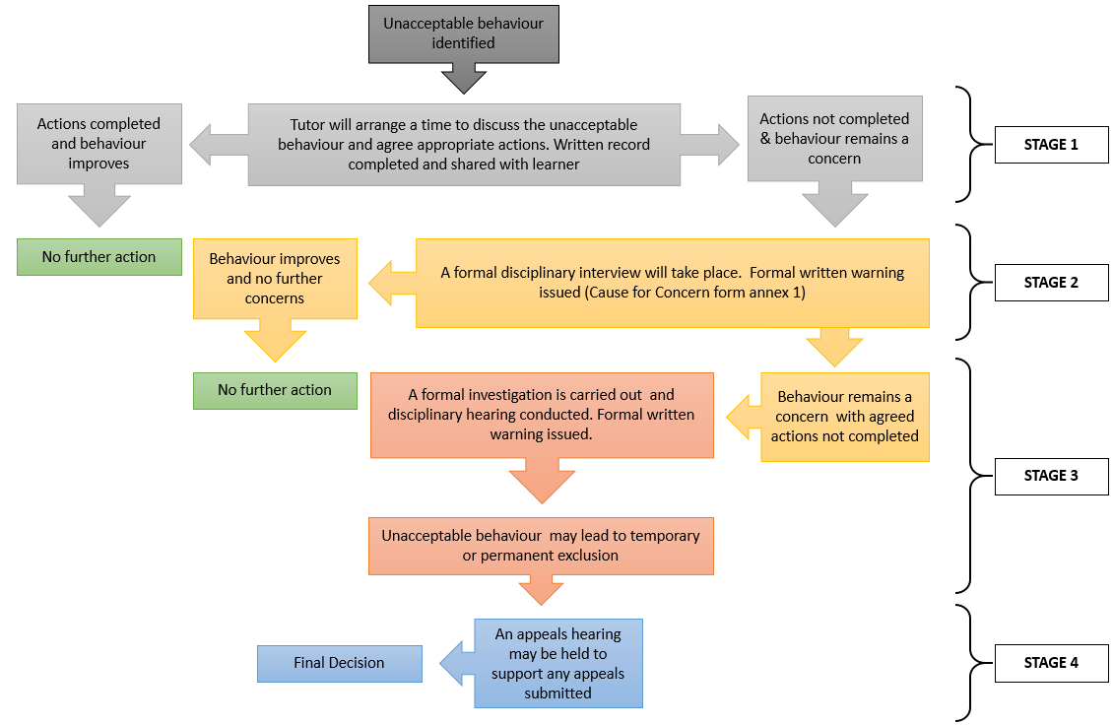

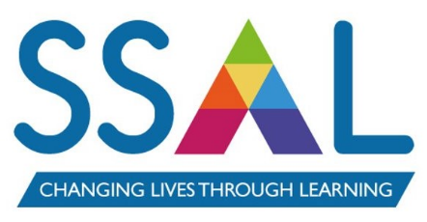
Annex 1

BEHAVIOUR
CAUSE FOR CONCERN

N.B. This form may be used as evidence so must be accurate and tidy

Learner Name:
Course Title:
Tutor Name:
Witness (if appropriate):

Report of Cause for Concern
(give details and date and whether this is a repeated cause of concern)

Record of Discussion with Learner

Agreed Further Action

Learner signature confirming their understanding of the content of this form
Signature: | Date:

Tutor Signature: | Date:
Original uploaded to learner file on EBS and a copy sent to the relevant manager

